### **Exalted Beltway**

Exalted Beltway is a self-hosted web server that allows users to directly download the torrent files by pasting the magnet link without any intrusion from Ads or viruses. I have worked on building this web server for my capstone project and I’d like to share some details regarding this project.

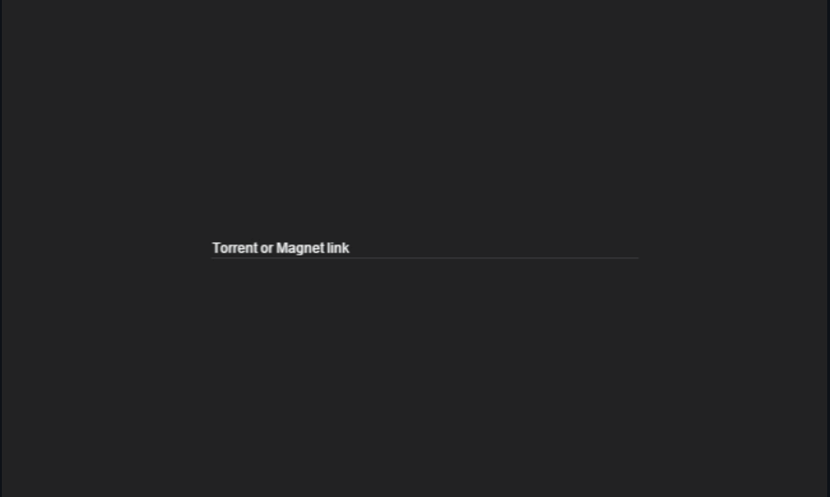

### **What Made Me Choose This Project And Who Could Use It**

In the internet age, information is at our fingertips. But many people are not able to access quality resources of big companies due to lack of money. This leaves them feeling left out. I had a similar case whereI couldn’t access most of the quality content for a number of reasons. Over the years, the government has also banned several torrent websites that kept me from viewing my favorite series, downloading various software, and other things I needed to make my life better. Due to this being a big problem for myself and other people like me, I decided to solve it with the skills I’ve developed from my CSE courses. People who regularly download files can use this web server. Young people like me who don’t have enough money to purchase the original content can use it too.

### **Components Utilized**

For the building and hosting the server — Exalted Beltway, I utilized Node.js for hosting the web server and JavaScript as the programming language. I learned the basics and the package deployment to implement a minimalist design and create the connection with the seeders of torrent files using the magnet link.

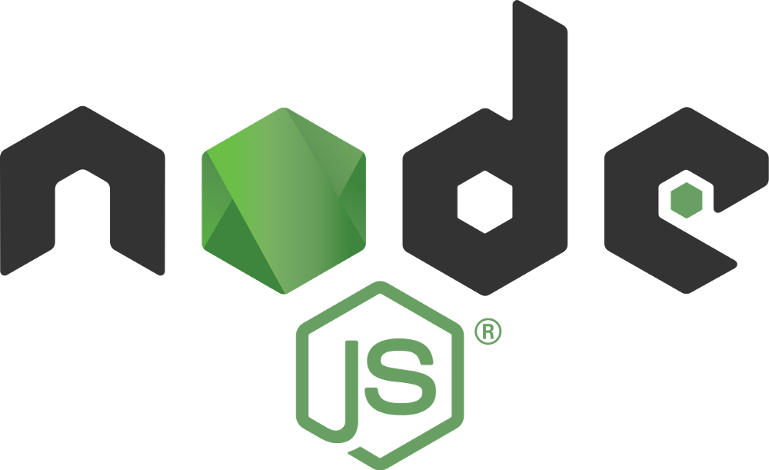

### **Benefits of the web server**

* Lightweight, fast torrent application
* Beautiful user experience
* Free, non-commercial, ad-free
* Instantly download files
* Opens magnet links and .torrent files

Here is the second page that comes after the user pastes the magnet link for the file on the home page which shows the user the desirable files:

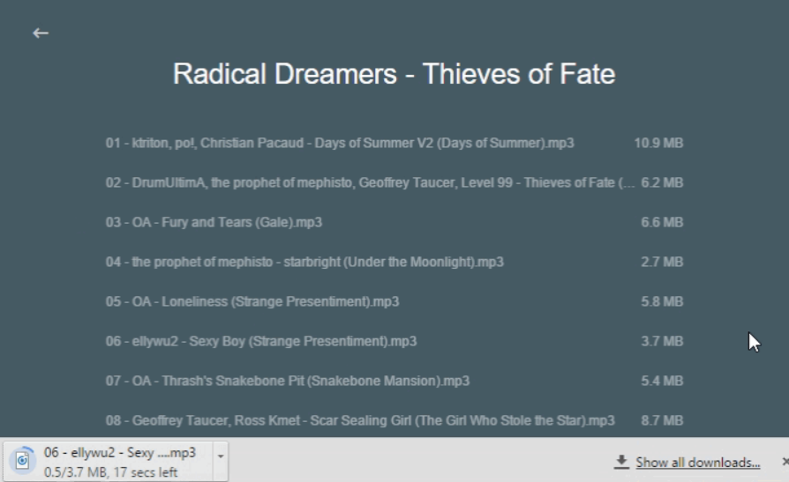

### **What I’ve Learned**

Over the course of this project, I have come to learn many technical skills:

* The basics of using Node.js and the repositories inside it.
* Learned the basics of JavaScript programming language and how to execute it to build a web server
* Learned the workings and uses of package managers to deploy multiple packages to run the web server

### **Conclusion**

The primary objective was to build a web server that could download the torrent files directly to the user's computer by only using the magnet link while providing a seamless UI without any ads or viruses. By using Node.js and JavaScript as the programming language I created the above-mentioned web server.

This was truly a wonderful learning experience for me where I had to learn how to use Node.js and implement JavaScript as the programming language to execute this idea from scratch.

Thank you to CSE Bennett for giving me the opportunity to execute this idea.

Link to the blog: https://medium.com/@pm7398/exalted-beltway-af5c9f12a32a